**Group Selfie**

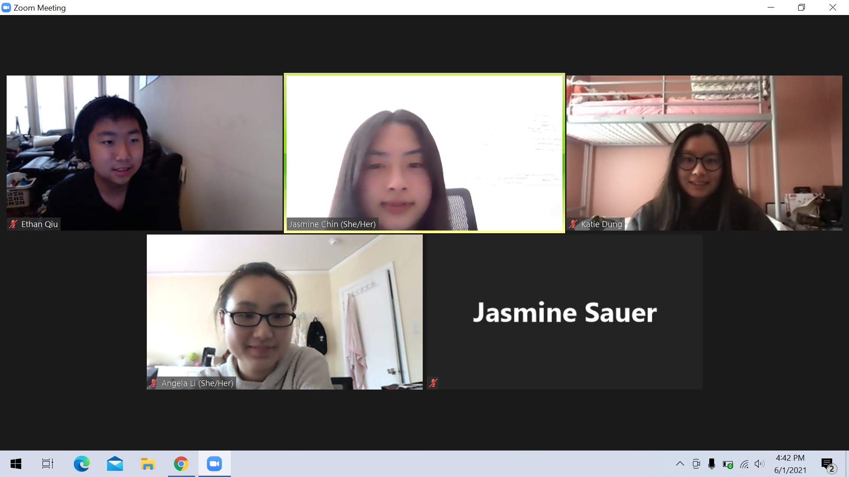

**Tallest in the Group**

Ethan

**Rock, Paper, Scissors**

Katie won against Nicole (rock beat scissors)!

**$100 at Target**

Jasmine Chin: I would get a wax warmer ($15) because I wanna feel relaxed with candle wax without having to burn a fire (be in risk of a fire).

Ethan: A super cool desk to replace my old one($50.00)

Katie: Takis because I’m craving it ($4.79)

Jasmine Sauer: anything baggy because it’s comfortable

**Eat, Save, and Throw Away**

Eat: Sardines

Save: Melted Butter

Throw away: Canned dog food

**Meet your MYEEP Buddies**

Katie Dung

* Email: [katieyanyan14@gmail.com](mailto:katieyanyan14@gmail.com)
* Phone number: (628)502-9628
* Instagram: @katiee.dung

Jasmine Chin

* Email: [jasmine.chin68@gmail.com](mailto:jasmine.chin68@gmail.com)
* Phone Number: (415) 385-3870
* Instagram: @jasminee_chin

Ethan Qiu

* Email: [ethanqiu.sf@gmail.com](mailto:ethanqiu.sf@gmail.com)

Jasmine Sauer

* Email: [jmoneyinthehouse68@gmail.com](mailto:jmoneyinthehouse68@gmail.com)
* Phone number: 415-942-4056
* Instagram: @jasmine.sauerr

**Describe Yourself**

Jasmine Chin: I would describe myself as energetic because I always have a lot of energy. For example, I am constantly laughing and talking, so many people say I have a lot of energy. I can also see myself being very active.

Ethan Qiu:

Easygoing because I can basically talk to everyone without causing an argument and other problems.

Katie Dung: positive because I don’t like negative vibes and I always try to encourage others

Jasmine Sauer: funny because i always get complimented about it

**Pancakes or Waffles?**

Waffles because its more interesting with its texture and

**Team Name**

**The Blue Iguanas**